**Evaluating Double Integrals**

copyright © 2009 by Jonathan Rosenberg based on an earlier M-book, copyright © 2000 by Paul Green and Jonathan Rosenberg

**Contents**

* [Evaluating Iterated Integrals](file:///M:\HTML%20files\doubleint.html#1)
* [Example 1](file:///M:\HTML%20files\doubleint.html#2)
* [Problem 1](file:///M:\HTML%20files\doubleint.html#6)
* [Finding the Limits](file:///M:\HTML%20files\doubleint.html#7)
* [Problem 2](file:///M:\HTML%20files\doubleint.html#23)
* [Integrating over Implicitly Defined Regions](file:///M:\HTML%20files\doubleint.html#24)
* [Problem 3](file:///M:\HTML%20files\doubleint.html#28)
* [Polar Coordinates](file:///M:\HTML%20files\doubleint.html#29)
* [Problem 4](file:///M:\HTML%20files\doubleint.html#32)
* [Additional Problems](file:///M:\HTML%20files\doubleint.html#33)

**Evaluating Iterated Integrals**

Evaluating a multiple integral involves expressing it as an iterated integral, which can then be evaluated either symbolically or numerically. We begin by discussing the evaluation of iterated integrals.

**Example 1**

We evaluate the iterated integral

$$ \int_0^1 \int_{1-x}^{1-x^2} \,xy\,dy\,dx. $$

To evaluate the integral symbolically, we can proceed in two stages.

syms x y

firstint=int(x\*y,y,1-x,1-x^2)

answer=int(firstint,x,0,1)

firstint =

(x^2\*(x - 1)^2\*(x + 2))/2

answer =

1/24

We can even perform the two integrations in a single step:

int(int(x\*y,y,1-x,1-x^2),x,0,1)

ans =

1/24

There is, of course, no need to evaluate such a simple integral numerically. However, if we change the integrand to, say, exp(x^2 - y^2), then MATLAB will be unable to evaluate the integral symbolically, although it can express the result of the first integration in terms of erf(x), which is the (renormalized) antiderivative of exp(-x^2).

int(int(exp(x^2-y^2),y,1-x,1-x^2),x,0,1)

Warning: Explicit integral could not be found.

ans =

int((pi^(1/2)\*exp(x^2)\*(erf(x - 1) - erf(x^2 - 1)))/2, x = 0..1)

However, we can evaluate the integral numerically, using **double**.

double(int(int(exp(x^2-y^2),y,1-x,1-x^2),x,0,1))

Warning: Explicit integral could not be found.

ans =

0.167491678970600

**Problem 1**

Evaluate the iterated integrals

$$\int_1^4 \int_{x}^{x^2} \,(x + y^3)\,dy\,dx.  $$

and

$$ \int_1^4 \int_{x}^{x^2} \,\cosh(x + y^3)\,dy\,dx. $$

**Finding the Limits**

We will now address the problem of determining limits for a double integral from a geometric description of the region of integration. While MATLAB cannot do that for us, it can provide some guidance through its graphics and can also confirm that the limits we have chosen define the region we intended. For a first example, we will consider the bounded region between the curves y = 2x+2 and y = exp(x). We begin by plotting the two curves on the same axes. You may need to experiment with the interval to get a useful plot; it should be large enough to show the region of interest, but small enough so that the region of interest occupies most of the plot.

y1=exp(x);y2=2\*x+2;

ezplot(y1,[-1,2]); hold on;

ezplot(y2,[-1,2]); hold off;

title('region bounded by y = 2x+2 and y = e^x')

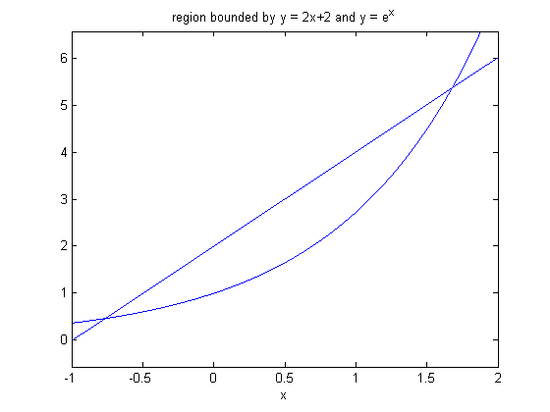

We can see from the plot that, to define the bounded region between the two graphs, exp(x) should be the lower limit for y, and 2x+2 should be the upper limit. In order to find the limits for x, we need the values for which the two functions coincide. We can try to use **solve** to find them.

solve(y1-y2)

ans =

- lambertw(0, -1/2\*exp(-1)) - 1

Hmm..., not clear what this means, but we can convert to numerical values:

lims=double(ans)

lims =

-0.768039047013466

That seems to be the lower limit, but there should have been an upper limit around 1.7. We can search for its numerical value using **fzero**:

lims(2) = fzero (@(t) subs(y1-y2, x, t), 1.7)

lims =

-0.768039047013466 1.678346990016661

Now that we have found the limits, we can use the following M-file **verticalRegion** to visualize the region they define so that we can check that it is the same as the region we had in mind. This program plots the two curves in two different colors: red for the function entered first, and blue for the function entered second, and shades the region in between in cyan.

type verticalRegion

function out = verticalRegion(a, b, f, g)

%VERTICALREGION is a version for Matlab of the routine on page 157

% of "Multivariable Calculus and Mathematica" for viewing the region

% bounded by two curves. f and g must be names of functions;

% a and b are the limits. The function f is plotted in red and the

% function g in blue, and lines are drawn connecting the two curves

% to illustrate the region they bound. The function g must have a variable

% in it, so if it's supposed to be a constant, try a fudge like

% '0 + eps\*x'.

var=findsym(g);

a=double(a);b=double(b);

%This guarantees these are floating point

% numbers and not just symbolic expressions like sqrt(2)

xx=a:(b-a)/40:b;

fin=inline([vectorize(f+var-var),'+zeros(size(',char(var),'))'],char(var));

gin=inline(vectorize(g+var-var),char(var));

plot(xx,fin(xx),'r');

hold on

plot(xx,gin(xx),'b');

for xxx=a:(b-a)/20:b,

Y=[fin(xxx), gin(xxx)];

plot([xxx, xxx], Y, 'c');

end

title(['region between ',char(f),' and ',char(g)])

hold off

verticalRegion(lims(1),lims(2),y1,y2)

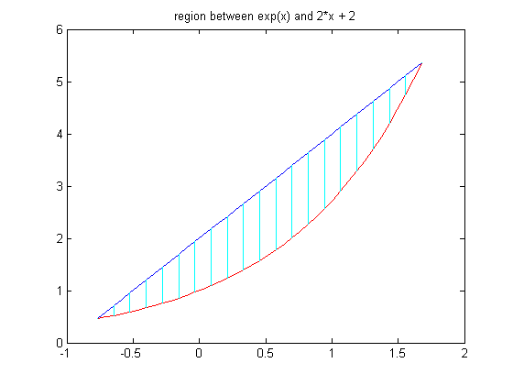

Evidently our limits define the right region. We can now use them to integrate any function we like over the region in question. To find the area of the region, for example, we integrate the function 1. Since our limits for x are numerical, a symbolic calculation is not of much use directly, so we use **double** to convert to a numerical answer.

area=double(int(int(1,y1,y2),lims(1),lims(2)))

area =

2.226964641160632

Of course, the area between two curves could just as easily have been evaluated as the integral of the difference between the two functions of x whose graphs define the region; that is to say the first integration in this case is so simple that one can write down the result as easily as the integral. However, we can also integrate any function we like over the same region, changing only the integrand. For instance:

newint=double(int(int(x^2+y^2,y,y1,y2),x,lims(1),lims(2)))

newint =

18.576868823773250

The numerical evaluation in this case was performed using numerical routines borrowed from MuPAD, which takes care of symbolic calculations. MATLAB has its own double integrator, called **dblquad**. There is a complication in using **dblquad**; it does not accept variable limits. Thus there are two ways to use **dblquad**:

1. expand the region of integration to a rectangle, and make the integrand = 0 outside of the region where one wants to integrate, or
2. make a change of variables in the inner integral. Fortunately, it is always the same one. We set y=y1+u(y2-y1) so that as u varies from 0 to 1, y varies from y1 to y2, and then integrate over x and u instead of over x and y. Note that dy=(y2-y1)du. This gives the identity

$$ \int_{x_1}^{x_2} \!\int_{y_1}^{y_2} \,f(x,y)\,dy\,dx = $$

$$ \phantom{x}\qquad \int_{x_1}^{x_2}\! \int_0^1\,f(x,y_1 + u(y_2 - y_1))(y_2 - y_1)\,du\,dx. $$

**dblquad** demands a vectorized **function** (not symbolic expression) as an input, depending on vector-valued **x** and scalar-valued **y**. We implement both methods, and use **format long** to compare the results.

format long

newint

newint =

18.576868823773250

Next, the method using integration over a rectangle bigger than the true region of integration. We have to multiply the original integrand **g** by something that is 0 outside the region of integration. But **y<=y2** is 0 (false) if **y>y2** and 1 (true) otherwise. Similarly, **y>=y1** is 0 (false) if **y<y1** and 1 (true) otherwise.

g = @(x,y) x.^2+y^2;

h = @(x,y) g(x, y).\*(y<=2\*x+2).\*(y>=exp(x));

newint1=dblquad(h,lims(1),lims(2),0,6)

newint1 =

18.078690871319640

Finally the method using a change of variables:

g = @(x,y) x.^2+y.^2;

h1 = @(x,u) g(x, exp(x)+u\*(2\*x+2-exp(x))).\*(2\*x+2-exp(x));

newint2=dblquad(h1,lims(1),lims(2),0,1)

newint2 =

18.576868790136942

The answers provided by all three methods are clearly in the same ballpark, and those produced by **int** and the change of variables method agree to eight significant digits. The method using "truncation" is less accurate, because it results in integrating a discontinuous function, whereas the usual algorithms for numerical integration work best with an integrand that is smooth.

Because of the syntactical complications of using **dblquad** on a region that is not rectangular, we have created M-files **symint2** and **numint2**, which have identical calling syntax and implement, respectively, symbolic double integration using **int**, and numerical double integration using **dblquad**. The advantage of the identical syntax is that if **symint2** fails, one can try **numint2** instead with a minimum of editing. We illustrate them by repeating the two previous computations.

type symint2

function out=symint2(integrand,var1,varlim1,varlim2,var2,lim1,lim2)

%SYMINT2 Symbolically evaluate double integral.

% NUMINT2 is basically a "wrapper" for iterated application of INT.

% The INNER integral should be written first.

% Example:

% syms x y

% symint2(x,y,0,x,x,1,2) integrates

% the function x over the trapezoid 1<x<2, 0<y<x,

% and gives the symbolic output 7/3.

% See also NUMINT2.

out=int(int(integrand,char(var1),varlim1,varlim2),char(var2),lim1,lim2);

type numint2

function out=numint2(integrand,var1,varlim1,varlim2,var2,lim1,lim2)

%NUMINT2 Numerically evaluate double integral.

% NUMINT2 is basically a "wrapper" for DBLQUAD, to

% get around the fact that the latter is only designed for integration

% over a rectangle, and requires inline vectorized input. The

% INNER integral should be written first.

% Example:

% syms x y

% numint2(x,y,0,x,x,1,2) integrates

% the function x over the trapezoid 1<x<2, 0<y<x,

% and gives the numerical output 2.3333.

% See also SYMINT2.

syms uU

newvar1=varlim1+uU\*(varlim2-varlim1);

integrand2=subs(integrand,var1,newvar1)\*(varlim2-varlim1);

integrand3=inline([char(vectorize(integrand2)),'.\*ones(size(uU))'],'uU',char(var2));

out=dblquad(integrand3,0,1,lim1,lim2);

double(symint2(sin(x^2+y^2),y,y1,y2,x,lims(1),lims(2)))

numint2(sin(x^2+y^2),y,y1,y2,x,lims(1),lims(2))

Warning: Explicit integral could not be found.

ans =

0.289216044183966

ans =

0.289216393390081

Note: As this example illustrates, in some problems, **dblquad** and **numint2** do not work that well, and spit out long lists of warning messages. In next week's lesson, we will discuss another package called **nit**, or "numerical integration toolbox", that usually corrects the problem.

**Problem 2**

Let R be the region bounded by the curves y=3\*x^2 and y=|2\*x+3|.

a) Determine the limits of integration for a double integral over R; confirm your limits by using **verticalRegion**.

b) Evaluate

$$ \int\!\int_R x\exp(-y^2)\,dA, $$

both using **double** and **int** (or **double** and **symint2**, and using **dblquad** (or **numint2**).

**Integrating over Implicitly Defined Regions**

Let us now turn to the process of integrating over a region bounded by a level curve of a function of two variables. Once again, the real issue is the determination of the limits of integration. We will consider the region bounded by the ellipse 3\*x^2+4\*y^2=37. Although it is not strictly necessary in this case, we will begin by plotting the ellipse.

ezplot(3\*x^2+4\*y^2-37, [-4, 4, -4, 4]), axis equal

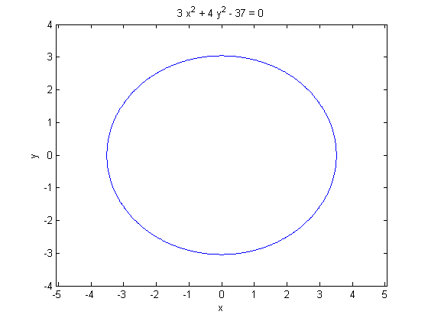

We can see from the plot that this region is vertically simple. We obtain our y limits by solving the equation of the ellipse for y in terms of x.

ylims=solve(3\*x^2+4\*y^2-37,y)

ylims =

-(37 - 3\*x^2)^(1/2)/2

(37 - 3\*x^2)^(1/2)/2

The two solutions give the upper and lower limits for y; we can find the limits for x by setting their difference to 0 and solving for x.

y1=ylims(2)

y2=ylims(1)

xlims=solve(y1-y2,x)

x1=xlims(2)

x2=xlims(1)

y1 =

(37 - 3\*x^2)^(1/2)/2

y2 =

-(37 - 3\*x^2)^(1/2)/2

xlims =

(3^(1/2)\*37^(1/2))/3

-(3^(1/2)\*37^(1/2))/3

x1 =

-(3^(1/2)\*37^(1/2))/3

x2 =

(3^(1/2)\*37^(1/2))/3

We can confirm our limits, using **verticalRegion**. The first two arguments to verticalRegion must be numerical, rather than symbolic. Therefore, we must apply double to x1 and x2. verticalRegion(double(x1),double(x2),y1,y2)

We can now integrate any function we desire over the region bounded by the ellipse.

**Problem 3**

Integrate

$$ \sqrt{x^2 + y^2 + 1} $$

a) Over the region bounded by the ellipse 3\*x^2+4\*y^2=36.

b) Over the region bounded by the curve x^4+y^4=20.

**Polar Coordinates**

We conclude this lesson with a discussion of integration in polar coordinates. We consider integrating the function exp(-x^2-y^2) over the disk bounded by the circle (x-1)^2 + y^2 = 1. We begin by expressing the function whose vanishing defines the boundary curve in polar coordinates.

syms r th

polarfun=simplify(subs((x-1)^2+y^2-1, [x,y],[r\*cos(th),r\*sin(th)]))

polarfun =

r^2 - 2\*r\*cos(th)

Next we solve the equation of the boundary curve for r in terms of theta, to obtain the limits for r.

rlims=solve(polarfun,r)

rlims =

0

2\*cos(th)

Since the disk in which we are interested lies entirely to the right of the x-axis, the appropriate limits for theta are -pi/2 and pi/2. Bearing in mind that we must include a factor of |r |when integrating in polar coordinates, we can now set up and evaluate an iterated integral in any of the usual ways. For example:

double(int(int(r\*exp(-r^2),0,2\*cos(th)),-pi,pi))

Warning: Explicit integral could not be found.

ans =

2.172385173883870

**Problem 4**

Reevaluate the integral above using **numint2**.

**Additional Problems**

1) Evaluate

$$ \int\!\int_R \,x^2 + y^2\, dA,$$

where R is the triangle with vertices at (0,0), (0,2) and (3,0). **Hint**: begin by determining the equation of the oblique side of the triangle. Use **verticalRegion** to confirm your limits.

2) Evaluate

$$ \int\!\int_R \,x\sin(y^2)\, dA,$$

where R is the region bounded by the closed curve

$$x^4 + y^2 = 8. $$

3) Evaluate

$$ \int\!\int_R \,\sqrt{x^2 + y^2 +r}\, dA,$$

where R is the region bounded by the cardioid

$$ r = 2 + 2\cos\theta.$$

4) Compute the area of the region bounded by the two curves x^2 - y^2 = 1 and y = x^2 - 3\*x + 1.

Published with MATLAB® 7.8